**Ex.No. : 07 Date:27.02.2025**

**RegisterNo.:221701004 Name:Adhithya A**

Telephonyservices

# Aim

ImplementanapplicationtogetTelephonyservices.

## Procedure:

**Step1:**File->NewProject

ProvidetheapplicationnameandClick“Next”

**Step2:**Selectthetargetandroiddevices

SelecttheminimumSDKtoruntheapplication.Click“Next”.

**Step3:**Choosetheactivityfortheapplication(Bydefaultchoose“BlankActivity).

Click “Next”.

**Step4:**Enteractivitynameandclick&quot;Finish&quot;.

**Step5:**Edittheprogram.

**Step 6:** Runtheapplication,2-waystorunthe application.

1. Runningthroughemulator
2. Runningthroughmobiledevice

**DepartmentofComputerScienceandDesign**| **RajalakshmiEngineeringCollege**

.

1

## AndroidManifest.xml

<manifest xmlns:android=["http://schemas.android.com/apk/res/android](http://schemas.android.com/apk/res/android)"package="com.example.ex8">

<uses-permissionandroid:name="android.permission.ACCESS_FINE_LOCATION"/>

<uses-permissionandroid:name="android.permission.READ_PHONE_STATE"/>

<uses-permissionandroid:name="android.permission.ACCESS_COARSE_LOCATION"/>

<applicationandroid:allowBackup="true"android:label="Telephony Info"android:theme="@style/Theme.EX8">

<activity android:name=".MainActivity" android:exported="true">

<intent-filter>

<actionandroid:name="android.intent.action.MAIN"/>

<categoryandroid:name="android.intent.category.LAUNCHER"/>

</intent-filter>

</activity>

</application>

</manifest>

## Activity_main.xml

<?xmlversion="1.0"encoding="utf-8"?>

<ScrollView xmlns:android=["http://sche](http://sche/) mas.android.com/apk/res/a ndroid"

2

**DepartmentofComputerScienceandDesign**| **RajalakshmiEngineeringCollege**

.

android:layout_width="match_parent"

android:layout_height="match_parent">

<LinearLayout

android:orientation="vertical"

android:padding="16dp"

android:layout_width="match_parent"

android:layout_height="wrap_content">

<TextView

android:id="@+id/tvTeleph onyInfo"

android:layout_width="match_parent"

android:layout_height="wrap_content"

**DepartmentofComputerScienceandDesign**| **RajalakshmiEngineeringCollege**

.

3

android:text="Telephony Info"

android:textStyle="bold"

android:textSize="16sp"/>

<TextView

android:id="@+id/tvLocatio n"

android:layout_width="match_parent"

android:layout_height="wrap_content"

android:text="Location"

android:textStyle="bold"

android:layout_marginTop

="20dp"

android:textSize="16sp"/>

<TextView

4

**DepartmentofComputerScienceandDesign**| **RajalakshmiEngineeringCollege**

.

android:id="@+id/tvAddres s"

android:layout_width="match_parent"

android:layout_height="wrap_content"

android:text="Address"

android:textStyle="bold"

android:layout_marginTop

="20dp"

android:textSize="16sp"/>

<Button

android:id="@+id/btnFetch"

android:layout_width="match_parent"

android:layout_height="wrap_content"

android:text="Fetch

Info"

**DepartmentofComputerScienceandDesign**| **RajalakshmiEngineeringCollege**

.

5

android:layout_marginTop

="30dp"/>

</LinearLayout>

</ScrollView>

## MainActivity.kt

6

**DepartmentofComputerScienceandDesign**| **RajalakshmiEngineeringCollege**

.

packagecom.example.ex7

importandroid.Manifest

import android.content.pm.PackageManager import android.location.Geocoder

importandroid.location.Location

importandroid.location.LocationManager import android.os.Bundle

importandroid.telephony.TelephonyManager import android.widget.Button

importandroid.widget.TextView

import androidx.appcompat.app.AppCompatActivity import androidx.core.app.ActivityCompat

importjava.util.*

classMainActivity:AppCompatActivity(){

privatelateinitvartvTelephonyInfo:TextView private lateinit var tvLocation: TextView private lateinit var tvAddress: TextView private lateinit var btnFetch: Button

privatevalLOCATION_PERMISSION=101

privatelateinitvarlocationManager:LocationManager

overridefunonCreate(savedInstanceState:Bundle?){ super.onCreate(savedInstanceState) setContentView(R.layout.activity_main)

tvTelephonyInfo = findViewById(R.id.tvTelephonyInfo) tvLocation = findViewById(R.id.tvLocation)

tvAddress= findViewById(R.id.tvAddress) btnFetch = findViewById(R.id.btnFetch)

btnFetch.setOnClickListener {if (checkPermissions()) {

displayTelephonyInfo() fetchLocation()

}else{

requestPermissions()

*}*

**DepartmentofComputerScienceandDesign**| **RajalakshmiEngineeringCollege**

.

7

*}*

*}*

privatefuncheckPermissions():Boolean{

return ActivityCompat.checkSelfPermission(this, Manifest.permission.ACCESS_FINE_LOCATION)== PackageManager.PERMISSION_GRANTED &&

ActivityCompat.checkSelfPermission(this, Manifest.permission.READ_PHONE_STATE) == PackageManager.PERMISSION_GRANTED

*}*

private fun requestPermissions() { ActivityCompat.requestPermissions(this,

arrayOf(Manifest.permission.ACCESS_FINE_LOCATION,Manifest.permission.READ_PHONE_STATE),

LOCATION_PERMISSION)

*}*

override fun onRequestPermissionsResult(requestCode: Int, permissions: Array<out String>, grantResults: IntArray) {

if (requestCode == LOCATION_PERMISSION && grantResults.isNotEmpty() && grantResults[0] == PackageManager.PERMISSION_GRANTED) {

displayTelephonyInfo() fetchLocation()

}else{

tvTelephonyInfo.text="PermissionDenied" tvLocation.text = "Permission Denied"

*}*

*}*

privatefundisplayTelephonyInfo(){

valtelephonyManager=getSystemService(TELEPHONY_SERVICE)as TelephonyManager

valinfo="""

NetworkOperator:${telephonyManager.networkOperatorName}SIM Country: ${telephonyManager.simCountryIso}

SIMOperator:${telephonyManager.simOperatorName} Phone Type: ${when (telephonyManager.phoneType) {

8

**DepartmentofComputerScienceandDesign**| **RajalakshmiEngineeringCollege**

.

TelephonyManager.PHONE_TYPE_GSM ->"GSM" TelephonyManager.PHONE_TYPE_CDMA ->"CDMA" else ->"Unknown"

*}}*

""".trimIndent()

tvTelephonyInfo.text=info

*}*

privatefunfetchLocation(){

locationManager=getSystemService(LOCATION_SERVICE)as LocationManager

if(ActivityCompat.checkSelfPermission(this, Manifest.permission.ACCESS_FINE_LOCATION)!=

PackageManager.PERMISSION_GRANTED)return

val location: Location? = locationManager.getLastKnownLocation(LocationManager.GPS_PROVIDER)

*?:*

locationManager.getLastKnownLocation(LocationManager.NETWORK_PROVIDER

*)*

if(location!=null){

val lat = location.latitude vallon=location.longitude

tvLocation.text = "Latitude: $lat\nLongitude: $lon" getAddress(lat, lon)

}else{

tvLocation.text="Unabletogetlocation."

*}*

*}*

privatefungetAddress(lat:Double,lon:Double){ val geocoder = Geocoder(this, Locale.getDefault()) try {

valaddressList=geocoder.getFromLocation(lat,lon,1) if (!addressList.isNullOrEmpty()) {

valaddress=addressList[0]

valfullAddress= address.getAddressLine(0)

**DepartmentofComputerScienceandDesign**| **RajalakshmiEngineeringCollege**

.

9

tvAddress.text="Address:\n$fullAddress"

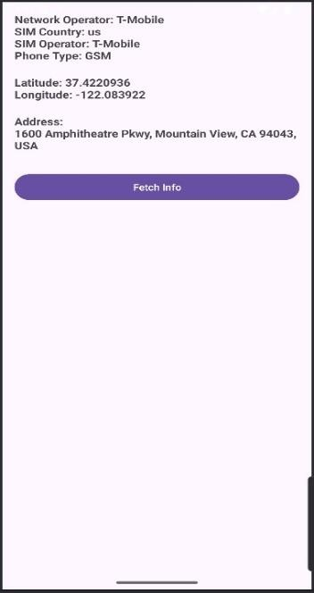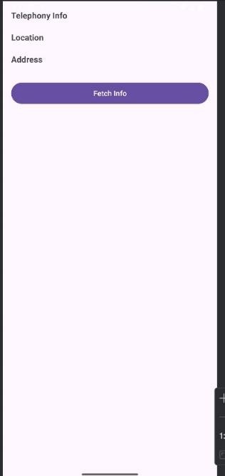

}else{

tvAddress.text= "Unabletoget address."

*}*

}catch(e:Exception){ e.printStackTrace()

tvAddress.text="Geocodererror:${e.localizedMessage}"

*}*

*}*

*}*

***Output****:*

# Result:

TheApplicationwasdevelopedusingKotlininAndroidStudio.

10 **DepartmentofComputerScienceandDesign**| **RajalakshmiEngineeringCollege**

.